CHINOOK DATABASE
The Chinook database is a relational database representing a digital music store. Business operations are modeled through interconnected tables containing customer, invoice, track, album and artist data. Relationships are established using primary and foreign keys, enabling transactional and analytical queries across sales, customer behavior and music catalog performance.
SQL QUERIES
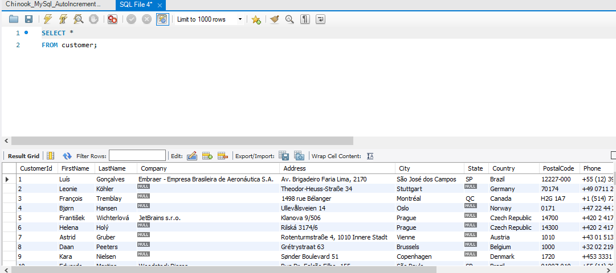
This helps us understand available customer attributes such as name, country and support representative before performing deeper analysis. This query shows us that there are missing company names, state and fax. States and fax fields are non-critical for analysis and reflect optional or deprecated customer attributes. Company field is analytically important, as it distinguishes between individual customers and corporate clients, enabling potential analysis.
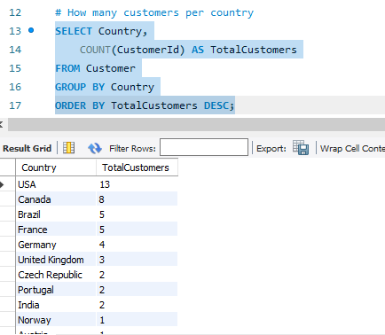
This query helps identify total customers in each country. Evidently, the USA has the largest number, followed by Canada. This indicates that there’s a stronger market penetration there and it is possibly the primary operational focus. Europe has a wide but shallow penetration, too. There is no African representation, suggesting limited market expansion, possible limitations.
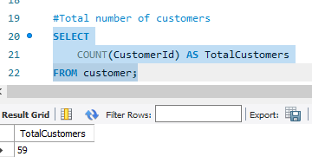
The total customer count provides a reference point for us, especially for further analysis.
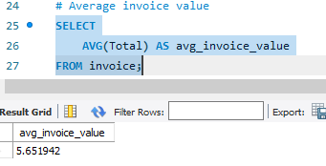
This helps us calculate the average spending per invoice and in the same vein, the average revenue generated by transaction.
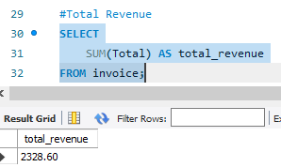
The total revenue query gives us overall business performance. It represents the sales performance of the digital music store. This value is relatively small, suggesting that this database is intended for educational purposes, rather than a representation of a large scale commercial environment.

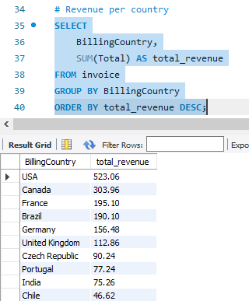
The revenue per country helps us group invoices by country. It calculates total revenue per country and it helps identify high-value markets. Evidently, the USA and Canada are currently leading, followed by some countries in Europe, Australia and South America. There is a positive customer-revenue relationship as countries with more customers generated more revenue
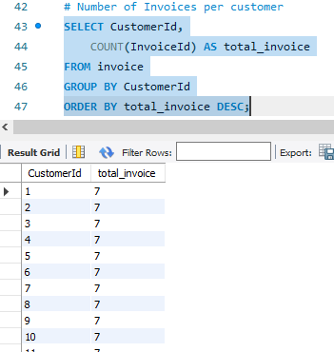
The number of invoices per customer shows how frequently each customer makes a purchase. The result of this query shows that most customers have 7 total invoices, with the remaining few having six total invoices. This shows a relatively balanced customer base with moderate repeat purchasing. 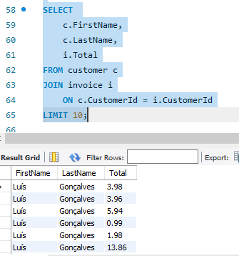
This query shows the transaction values of individual customers. The join operation reveals customer purchasing activity and demonstrates the one-to-many relationship between customers and invoices.
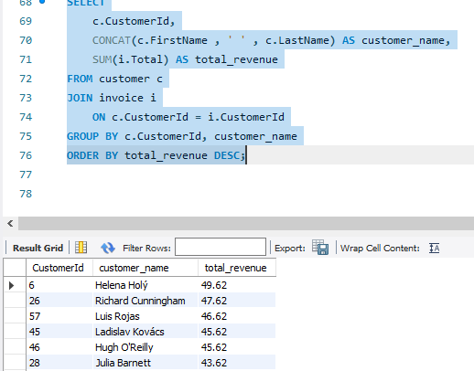
This query helps to understand the total revenue generated by each customer, by combining customer and invoice data. This analysis helps us understand that spending is equally distributed among customers.
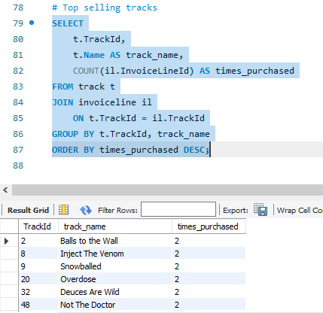
For the top selling tracks analysis, I linked track information with invoice transaction records and realized that a lot of tracks were purchased the same number of times, which is twice. So, they equally perform the same way.
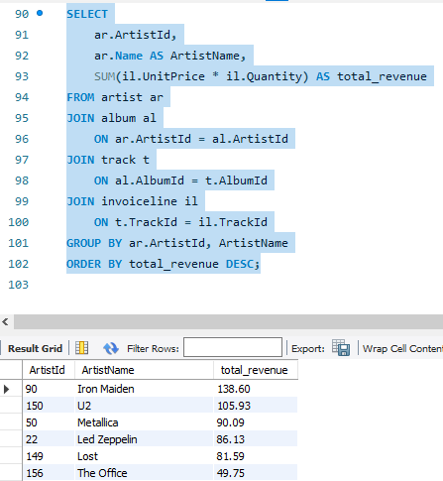
For top performing artists analysis, I evaluated artist sales performance by linking artist, album, track and invoice line tables. This analysis helps us identify the highest-performing artist based on generated sales revenue and demonstrates how relational database structures support complex business analysis.
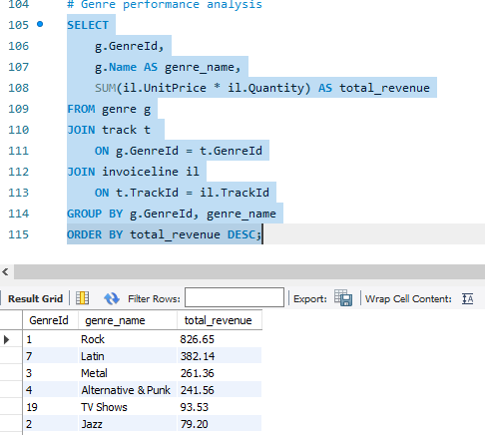
In answering the question of “Which music categories perform the best financially?”, I observed that Rock led with $826.65 in revenue followed by Latin, Metal and Alternative & Punk. There are genres that are performing weakly which might be caused by some genres containing more tracks or some genres being more frequently published.
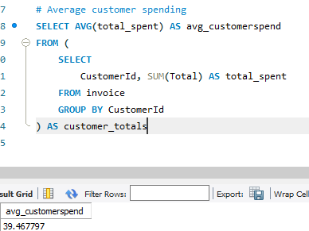
This helps us know how much a customer spends on an average. We take it a step further to determine the customers that spend above average
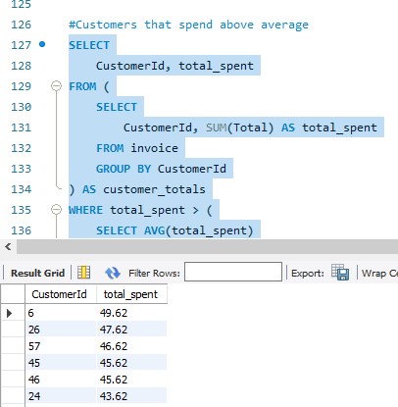
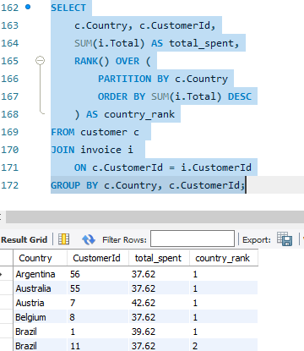
I used window functions to rank customers based on total spending globally and within each country. This analysis reveals customer hierarchy based on spending behavior and enables segmentation within geographic regions.

This analysis explored the Chinook relational database using SQL to understand customer behavior, revenue distribution and product performance. Through structured querying techniques including joins, aggregations, subqueries and window functions, meaningful insights were generated across customers, countries and music categories. Optimization practices such as selective querying, efficient joins and readable SQL structure were also applied to ensure scalability and clarity of analysis.

